**Project Development Phase**

**Sprint 1**

|  |  |
| --- | --- |
| Team ID | PNT2022TMID13652 |
| Project Name | Smart waste management system for  metropolitan cities |
| Maximum Marks | 8 Marks |

Python script and output:

Python script:

Code for smart waste management for metropolitan cities:

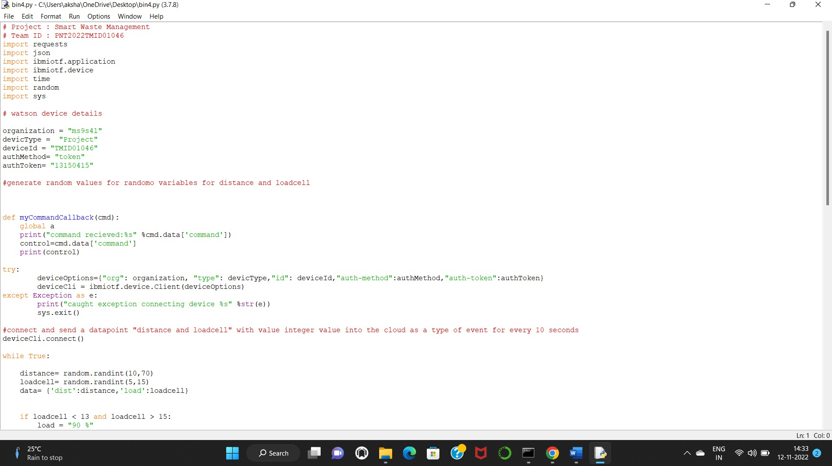

**OUTPUT: PYTHON IDLE**

The output of the smart waste management system was seen in the python idle .

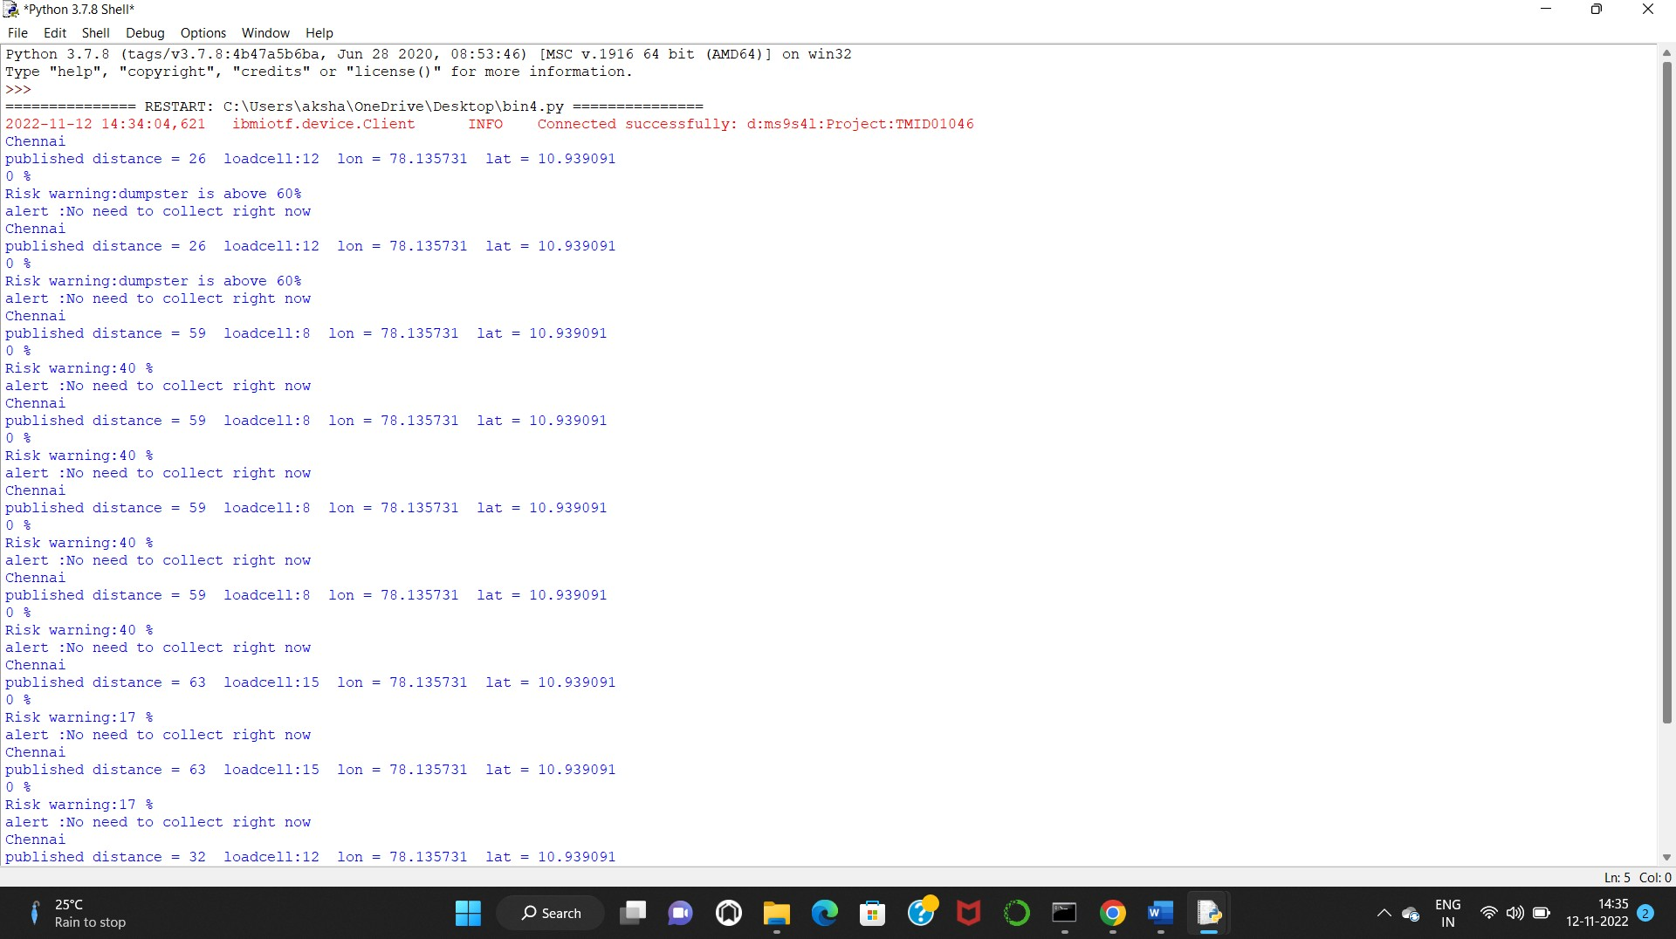

**CONCLUSION:**

In sprint 1, we depicted the python code for smart waste management system , in which we connected the sensor to detect the trash level as well as the obstacles using the sensors which helps to give the necessary information regarding garbage collection.